**Practical - 5(A)**

**Aim:** Write a program to show implementation of Interface.

Program Code:

interface animal{

    public void animalSound();

    public void eat();

}

class dog implements animal{

    public void animalSound(){

        System.out.println("Dog says bow bow");

    }

    public void eat(){

        System.out.println("Dog eat pedigree");

    }

}

public class interfaceTest {

    public static void main(String args[]){

        System.out.println("Name: Sudhanshu Prasad");

        System.out.println("RollNo: 132");

        dog d1 = new dog();

        d1.animalSound();

        d1.eat();

    }

}

**OUTPUT**

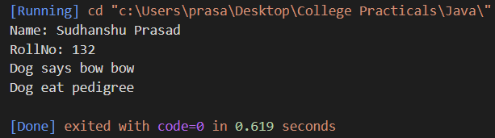

**Practical - 5(B)**

**Aim:** Write a program to show implementation of abstract class.

Program Code:

abstract class Animal{

    public abstract void animalSound();

    public void eat(){

        System.out.println("Cow eats husk");

    }

}

class cow extends Animal{

    public void animalSound(){

        System.out.println("Cow says moo");

    }

}

public class abstractTest {

    public static void main(String args[]){

        System.out.println("Name: Sudhanshu Prasad");

        System.out.println("RollNo: 132");

        cow c1 = new cow();

        c1.animalSound();

        c1.eat();

    }

}

**OUTPUT**

**Practical - 5(C)**

**Aim:** Write a program to show implementation of packages.

Program Code:

package Sudhanshu;

public class pkg {

    public void details(){

        System.out.println("Name: Sudhanshu Prasad");

        System.out.println("Age: 20");

        System.out.println("Roll No: 132");

        System.out.println("Branch CSE-C");

        System.out.println("Gender: Male");

    }

}

import Sudhanshu.*;

public class packageTest {

    public static void main(String args[]){

        pkg p1 = new pkg();

        p1.details();

    }

}

**OUTPUT**

